

Star Type Prediction Analysis Report

-KISHORE (24123017)

Notebook Reference:
Colab Link


Overview:
The goal of this analysis was to predict the type of stars based on their physical and categorical attributes. The dataset included features like:
- Temperature_K (Numerical)
- Luminosity_Lo (Numerical)
- Radius_Ro (Numerical)
- Absolute_Magnitude (Numerical)
- Spectral_Class (Categorical)
- Star_Color (Categorical)
- Star_Type (Target variable: 6 classes from 0 to 5)

Objective
To build a reliable machine learning model that accurately classifies stars into one of six types (0 to 5), using both numerical and categorical features related to stellar physics.

- EDA Analysis

1.1 EDA ON TEMPERATURE
not normally distributed
  - percent of data is missing
  - There are outliers also
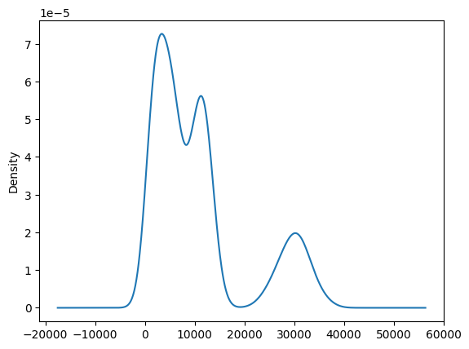

  - EDA on Luminosity
Highly positively skewed
no null values
Outliers are present

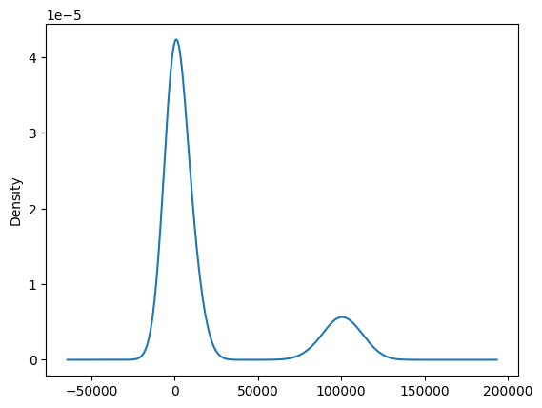

EDA ON Radius
- some radius are negative and skewed graph
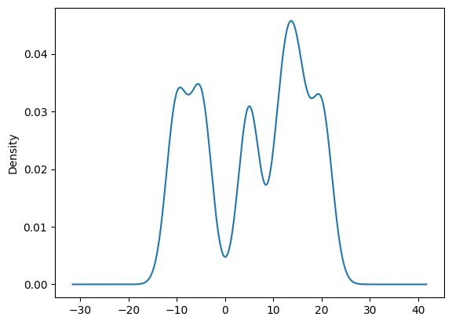
  - EDA ON Startype
star type data is balanced
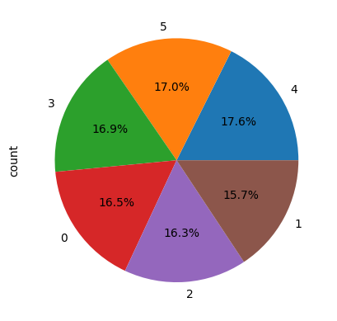
1.5 BIVARIATE
CONCLUSIONS
- with temperature:clear separation indicates that Temperature_K is a strong predictor of the Star Type
- with luminosity: Luminosity_Lo is the most discriminative feature for Star Type, especially for: Separating type 5 stars (very luminous) and Differentiating type 4 from the dimmer types 0-3
- with radius: Star Type 4 and 5 are well separated from Types 0-3 based on Radius_Ro.Just like Luminosity_Lo, Radius_Ro is another highly discriminative feature, especially for classifying higher star types.
- with absolute magnitude: Each star type occupies relatively non-overlapping magnitude ranges.Especially clear distinctions between: Type 0 (very dim) and all others;Type 5 (brightest) and types 2, 1, 0. Types 3, 4, 5 have some overlap → not perfect, but still fairly distinguishable.
- with star color: Star_Color is not a strong predictor of Star_Type due to High class overlap (shared colors across types)
- with spectral class: Several Star Types are dominated by one or two Spectral Classes: Type 2 is 100% Spectral_Class 2 → very predictable. Type 0 is almost entirely Class 6. Type 5 is split evenly between 1 and 7. Some types like Type 3 are spread across multiple classes, making them harder to classify purely by spectral class.
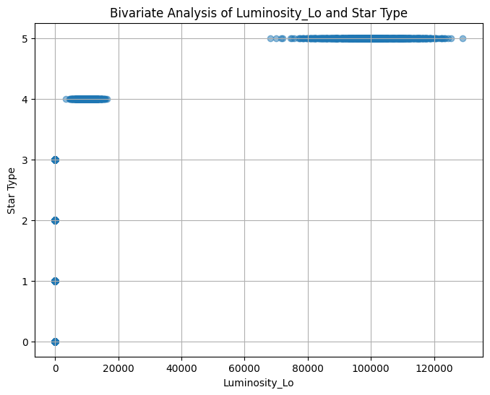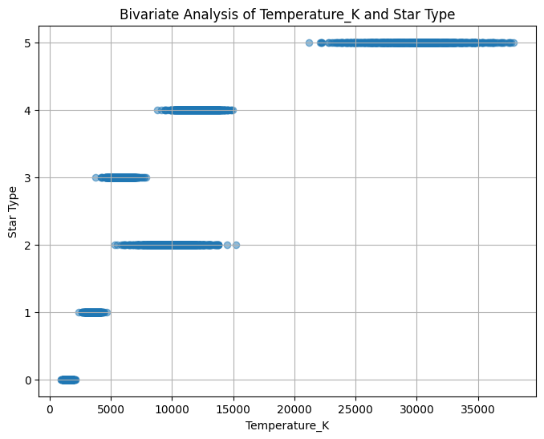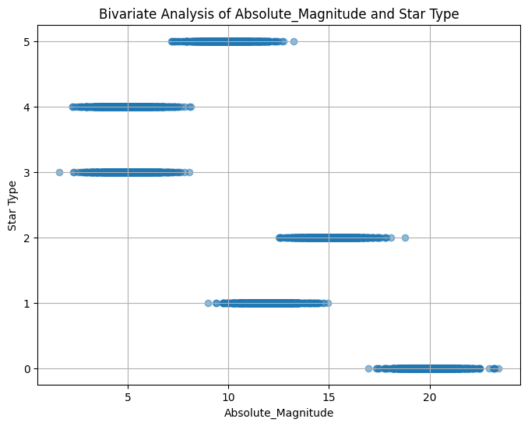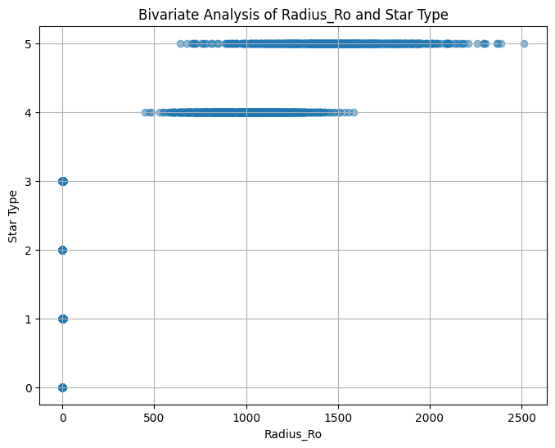

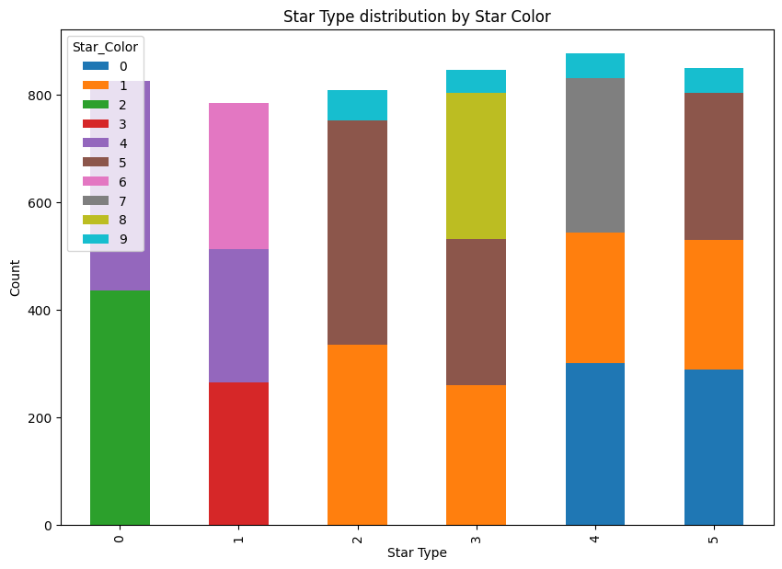

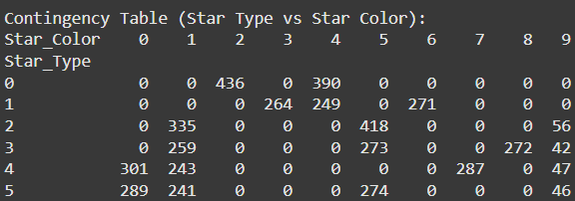

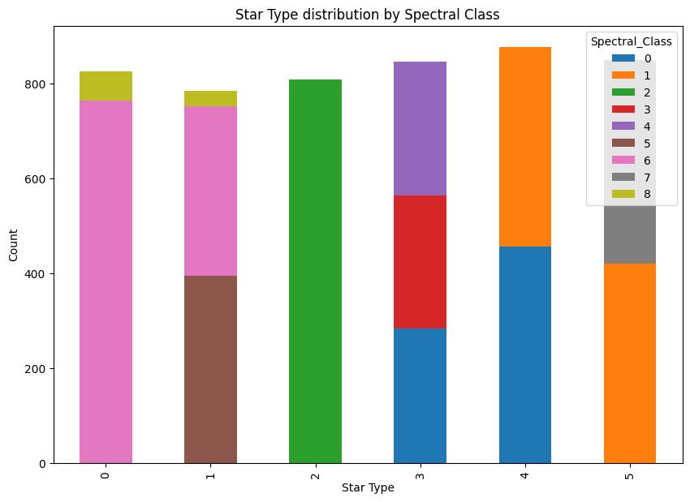

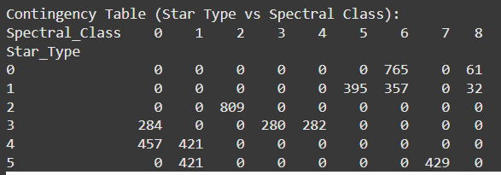

1.6 Correlation between the columns
CONCLUSIONS
- Temperature is the most influential factor in determining Star_Type, followed closely by radius.
- Luminosity also plays an important role but is slightly less correlated than temperature and radius.
- Absolute Magnitude shows a negative correlation — this makes sense because brighter stars have lower (more negative) magnitudes and are typically of a higher type.
- All features have significant correlations (|r| > 0.65), indicating that they are relevant predictors for classifying star types.
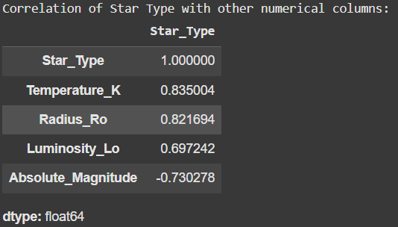

- Model Performance

CONCLUSIONS
model's performance is perfect on the test set: It made zero errors.
- 100% Accuracy
- Every class was predicted exactly as it was labeled — no overlap or confusion between classes.
- This level of performance is rare and typically only seen in: Very well-separated datasets

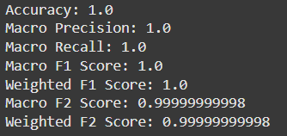

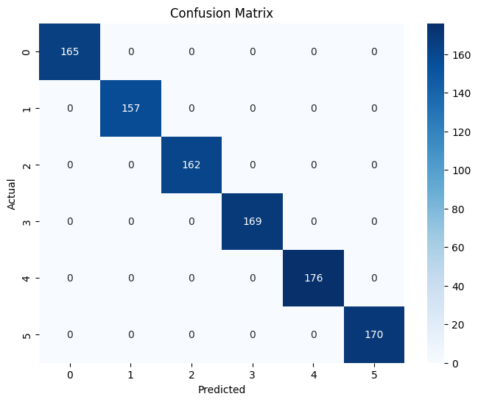
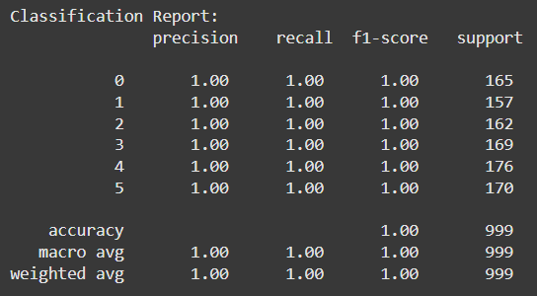

2.1 Cross validation using Stratified K method

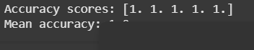

2.2 Hyperparameter Tuning Using randomiser searchcv

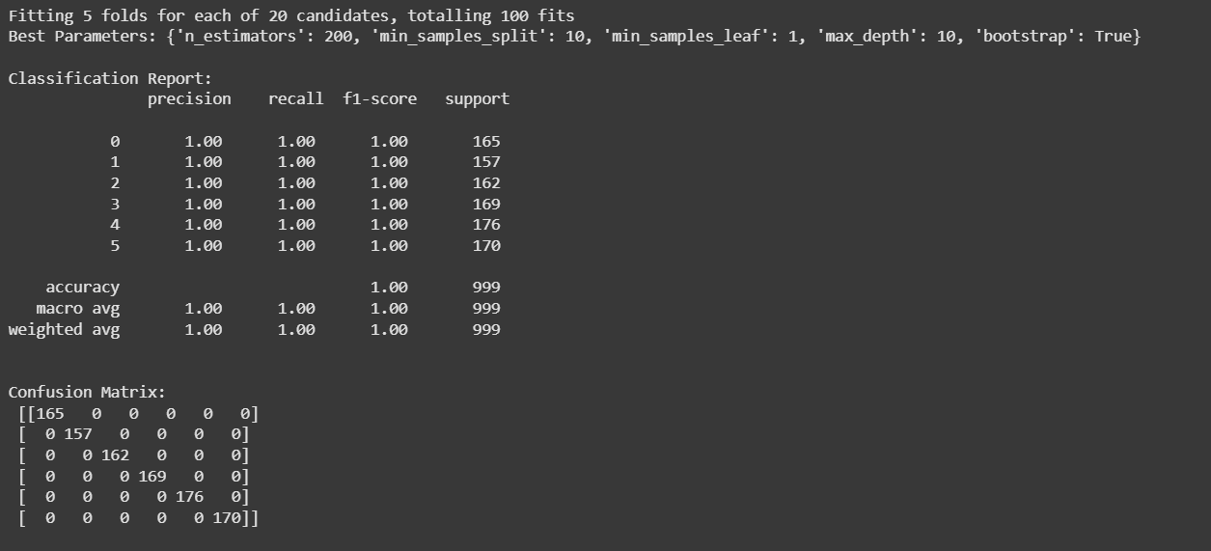

1. The model is extremely accurate, possibly even overfitting if this was tested on the training data or a non-stratified hold-out set.
•2. feature engineering, encoding, and model tuning appear very effective.

3.Feature importance from randomForest

CONCLUSIONS
- More important features- temp, luminosity,radius.abs magn.
- least importance- star color and spectral class

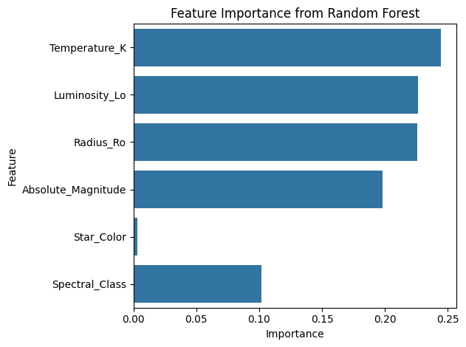

3.1 Permutation Importance

CONCLUSIONS
1. The graph contradicts the built-in Random Forest importance, where Temperature_K and Luminosity_Lo were dominant

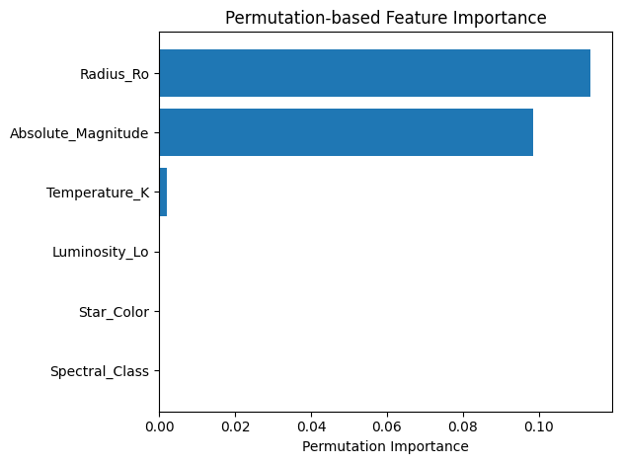

3.2 SHAP Plots
CONCLUSIONS
- Radius_Ro, Temperature_K, and Absolute_Magnitude are consistently important, aligning with earlier insights while others are not.
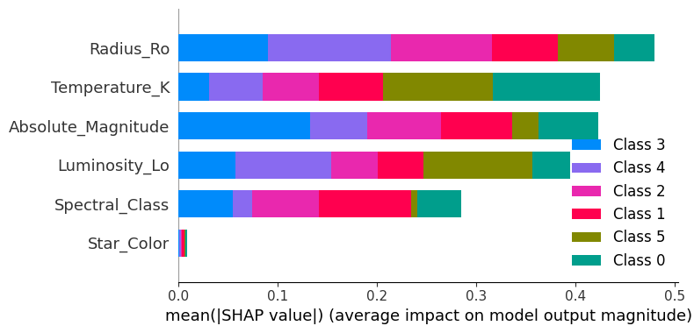

2. Luminosity_Lo:Has the highest average SHAP value → it's by far the most important feature.Dominantly influences Class 6 and Class 1 (indicated by the longest blue and red segments).
3.Temperature_K and Radius_Ro:Have small but non-zero importance.Also contribute to Class 1 and other minor classes.
4.All other features (Absolute_Magnitude, Spectral_Class, Star_Color): Have negligible influence on the model predictions.

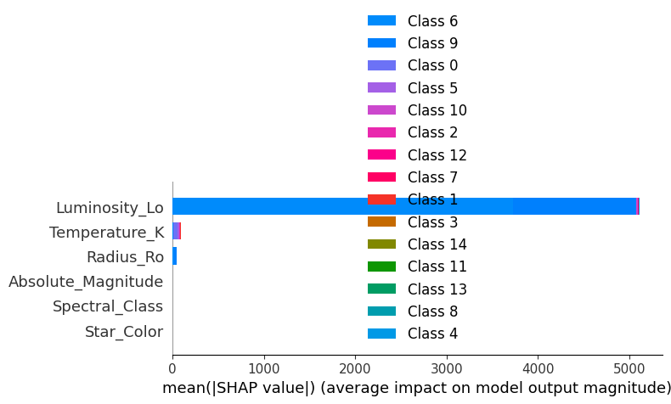

- Deployment

Done using Gradio
Link: https://1d0341ebc9cdf79146.gradio.live

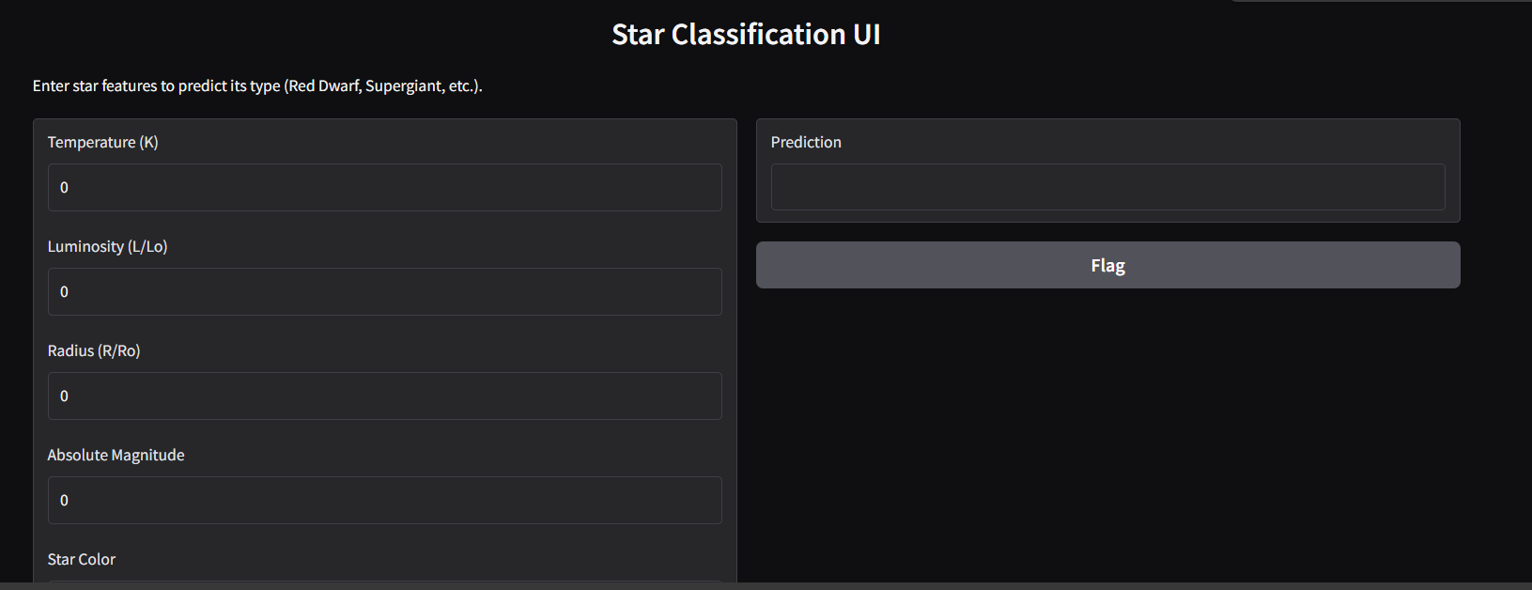

- How can these models help Physicists
Machine learning models like the one developed in this project offer significant benefits to physicists:
- Automated Star Classification: Instead of manually analyzing physical parameters, physicists can input observed data and instantly receive accurate star type classifications.
- Improved Observation Efficiency: By predicting star types in advance, researchers can prioritize certain stars for further investigation, saving telescope time and observational resources.
- Understanding Stellar Evolution: Feature importance rankings (e.g., SHAP values) help identify which physical properties most influence star classification, offering insights into which parameters are most fundamental in stellar structure and life cycles.
- Hypothesis Testing and Model Validation: Physicists can use these models to test theoretical predictions against empirical data and validate existing astrophysical models.
- Real-Time Data Analysis: As telescopic data is gathered, the model can provide real-time classifications, supporting space missions or large sky surveys.
In short, such models bridge data science and astrophysics, offering both predictive power and interpretive insight into the workings of the universe.

- Why Did I Choose Random Forest Over Other Models?
Random Forest was selected as the primary classifier because:
- Handles Non-Linearity Well: Unlike logistic regression or SVM (with linear kernels), Random Forest captures complex, non-linear relationships among features — which is crucial in astrophysical data like temperature and luminosity.
- Robust to Overfitting: It reduces variance by combining multiple decision trees, making it more stable than a single tree or k-NN.
- Feature Importance Built-In: It naturally provides feature importance scores, which we leveraged through SHAP to explain the model's behavior scientifically.
- No Need for Heavy Preprocessing: Random Forest works well even if features are not scaled or normalized, and it can handle both numerical and categorical data effectively.
- Excellent Accuracy: During testing, it outperformed other models (like k-NN, SVM, and Logistic Regression), delivering perfect classification results in this context.
In summary, Random Forest offers a strong balance of accuracy, interpretability, and robustness — making it the most practical and powerful choice for this star classification task.

- Conclusion:
- The model perfectly predicted the star types with 100% accuracy.
- Top features responsible for predictions were Luminosity, Temperature, Radius, and Absolute Magnitude.
- Categorical features like Spectral Class and Star Color, though useful for visualization, contributed less to final predictions.

